About us: Tsinghua HPGC

The Tsinghua High Performance Geo-Computing (HPGC) research group was founded in the year of 2011. The group has been led by Dr. Haohuan Fu, who worked in Tsinghua University as an associate professor since Dec, 2010.

As a computer scientist who has been working in the geoscience domain for years, Dr. Fu set up the group to promote the fusion of HPC technologies and geoscience applications, and to provide training and education for postgraduate students that would develop knowledge and expertise in computer science, computational mathematics, and geoscience.

The methodology that the HPGC tries to develop is to tackle research and engineering challenges from a combined perspective that consists of the geo-science application at the top, the numerical algorithm in the middle, and the hardware architecture at the bottom. Through a systematic approach that tries to arrive at the optimal option from all three different angles, we are striving to provide the best HPC solution for various geoscience applications. We are also in close cooperation with National Supercomputing Wuxi Center, which hosts the world's fastest supercomputer, and has the potential to bring breakthroughs in various methods in scientific domains.

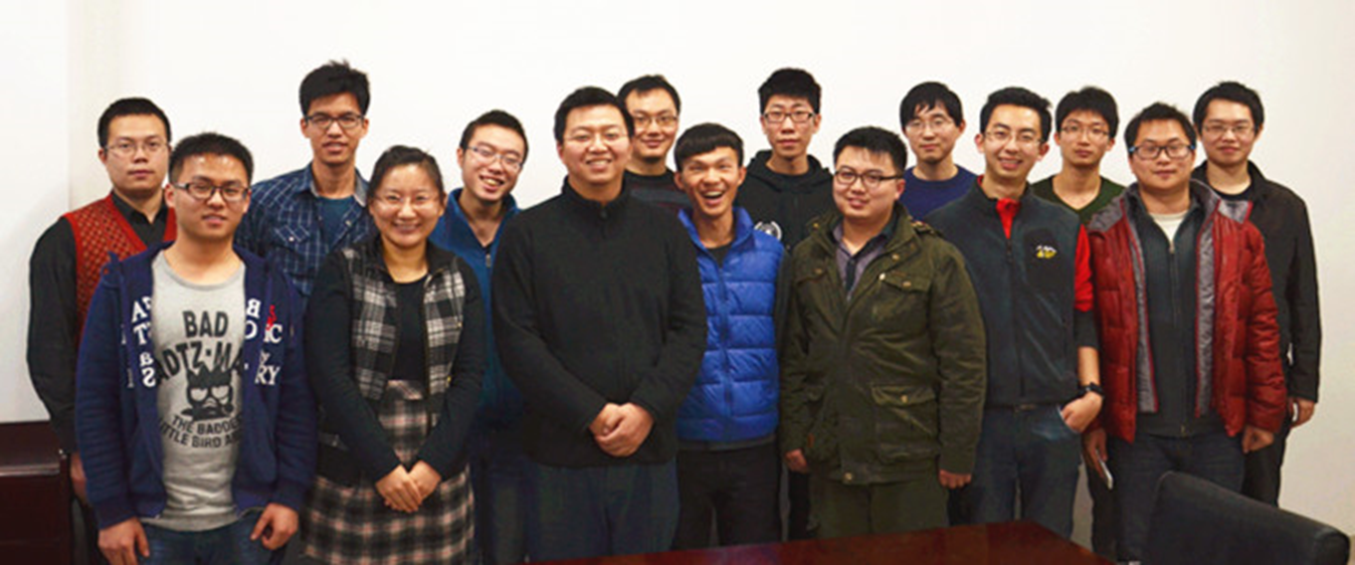The HPGC group currently includes 15 young and passionate research students, of which 1 is a PostDoc Fellow, 9 are PhD candidates, 3 are Master candidates, and 2 final year undergraduates who would join the group next year. While the current research activities cover a wide spectrum of topics (geophysics exploration, climate modeling, data mining for geo-scientific data, water plant layout planning, etc.), the focus has always been applying HPC technology to accelerate the computation, the data analysis, and even the new scientific discoveries in corresponding domains.